Hong Kong Mahjong Game Project

1. Requirement

* This game demo:

<http://play.agames.hk/index_2/game/bump/index.php>

<https://play.agames.hk/index_2/>

* Game Logic.

The logic of this project is similar to 80% of the demo game.

The remaining logic will be discussed later.

* This game has to be developed from the scratch.
  + Game UI
  + 3D models
* This game is a multiplayer game and contains AI.
* Product
  + PC
  + Mobile (IOS & Android)
  + Web

**NOTE:** If you have any specification, please let me know or add it here.

1. Dialog

* Select character

Man

Women

Nick Name

Password

Login

* Lobby Diagarm 1.

User Info

(name, Coin..)

打工區

金幣區

摘星賽

軍團戰

Room1

Room2

Room3

Room4

Room5

Room6

Pagination

* Lobby Diagram 2

User Info

(name, Coin..)

打工區

金幣區

摘星賽

軍團戰

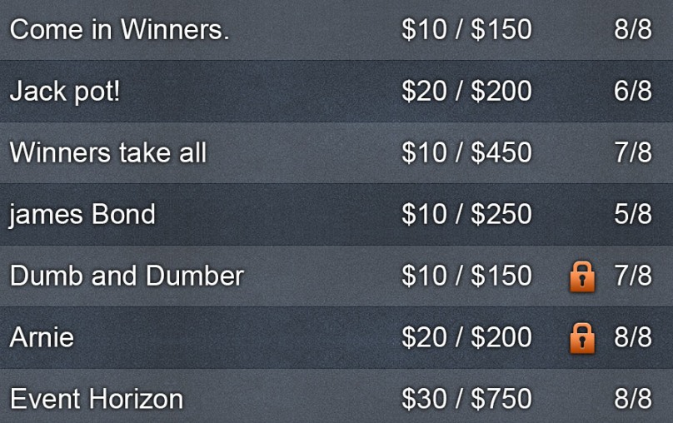

* Room

Table

Player Info

AI

1. System Design

* 3D Mode & Art and UI Design:
  + 3D models & Art

Mahzong, Table, male and female 3D characters (or 2D character).

* + UI
    - Choose Character
    - Lobby UI
    - Room UI
    - Buttons
    - Shop UI
    - Setting UI
* Offline Game
  + Player Controller
  + AI Controller
  + Animation
    - Button
    - Character
    - Mahjong
    - UI
    - Loading
    - Winner
    - Effect
* Online Multiplayer
  + Convert Character to Photon Character
  + Making Lobby UI & Controller
  + Creating Photon Network
  + Convert Mahjong to Photon Mahjong
  + Create Stream controller

1. Expected Milestone

* After 3 days, showing simple mahjong demo. ($500)

Simple features, basic UI included

* Design & Offline milestone 1 ($1500)
  + basically design
* Design & Offline Milestone 2 ($2000)
  + Mahjong AI
* Online Multiplayer Milestone 1 ($2000)
  + Convert to offline to Online (include lobby)
* Online Multiplayer Milestone 2 ($2000)
  + Complete (Adding Audio)